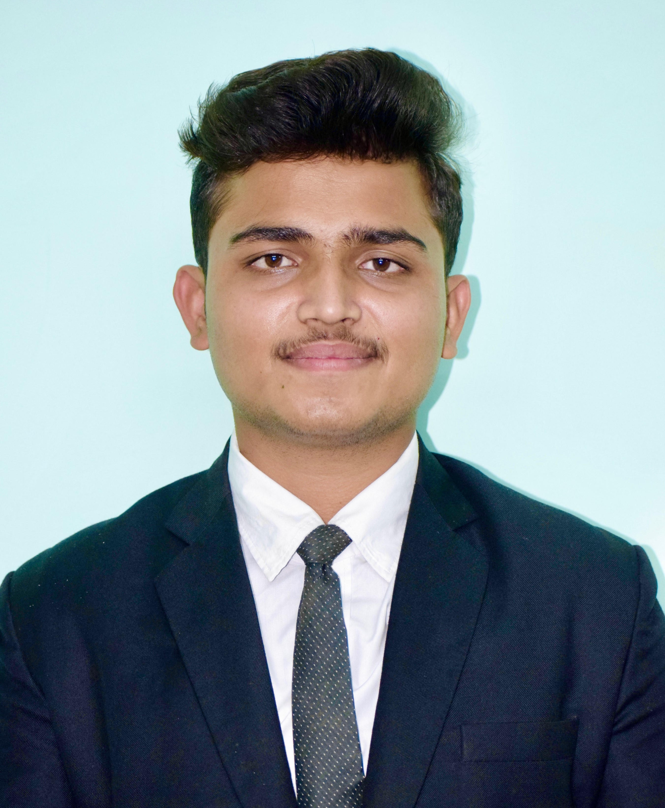

**RESUME**

# NAME - MR. BHAVESH RAVINDRA LANDGE

**COURSE - PGDM-ABM.**

**MOBILE NO -** +91 7030799397

**EMAIL ID -** [**landgebhavesh2017@gmail.com**](mailto:landgebhavesh2017@gmail.com)

# CAREER OBJECTIVE

* To obtain a high level of excellence in the growth oriented organization also to utilize myself as a resource for all kinds of challenging duties by upgrading my knowledge and skills.
* To Secure a Challenging Position in a reputable Organization to expand my learning, knowledge and skills.

# ACADEMIC PROFILE

|  |  |  |  |  |  |
| --- | --- | --- | --- | --- | --- |
| **Sr.No** | **QUALIFICATION** | **NAME OF SCHOOL /**  **COLLEGE** | **BOARD /**  **UNIVERSITY** | **YEAR OF**  **PASSING** | **PERCENTAGE**  **/CGPA** |
| 1. | B. Tech. Agricultural Engineering | K.K. Wagh College Of Agricultural Engineering &  Technology Nashik | MPKV Rahuri | 2022 | 7.6 |
| 2. | H.S.C | Dr D.A. Ohara Junior College ,Sangamner | Pune University | 2018 | 67.54% |
| 4. | S.S.C | Sahyadri  Vidyalaya,Sangamner | Pune University | 2016 | 80.40% |

**Work Experience :-**

* 1 year experience in APTIV PVT .LTD. in Quality Department as a Team Leader.
* Over 4+ Months of Quality Department in Dreamplast india Pvt.Ltd, Chakan.





**STRENTH & SKILLS**

* Commitment towards work assigned confidently.
* Ability to make ethical decision as per different aspect of situation.
* Team working person.
* Self-Motivated.

**INDUSTRIAL TRAINING :-**

* Completed One month implant training programme in **Mahindra Excellence Center,Nagpur Zahirabad**
* Completed One month implant training programme in **Integral Rural And Agricultutral Development Assiociation(IRADA),** Satara on **“Advance Irrigation & Precision Agriculture”.**
* Completed five month In-plant training in Digital Marketing Department at **MITRA AGRO EQUIPMENTS PVT.LTD, Nashik.**

**COMPUTER SKILLS**

* Compelted **MS-CIT** With **95%** in **Aug-2016**.
* MS OFFICE.
* Software Language: **HTML, CSS,** Responsive Web Design Certification.

|  |  |
| --- | --- |
| **PERSONAL PROFILE** | |
| Name - | **Landge Bhavesh Ravindra.** |
| Date of Birth - | 13/03/2001 |
| Gender - | Male |
| Marital Status - | Unmarried |
| Blood Group - | O+ (Positive) |
| Nationality - | Indian |
| * Language Known - Marathi, Hindi, English. * Address - A/P –Wadgaon Landga, Tal- Sangamner, Dist- Ahmednagar. (422605) | |

|  |  |  |
| --- | --- | --- |
|  |  |  |
|  | **EXTRA CURRICULAR ACTIVITIES**:-   * Participated as coordinator and volunteer in Technical Functions. * Participation in Social Welfare Activities . |  |
|  | **DECLARATION**  **I hereby declare that the above mentioned information is correct up to my knowledge; I bear the responsibility for the Correctness of above mentioned particulars.**  Date - / / 2022  Place- **Signature**  ( Bhavesh Ravindra Landge ) |  |